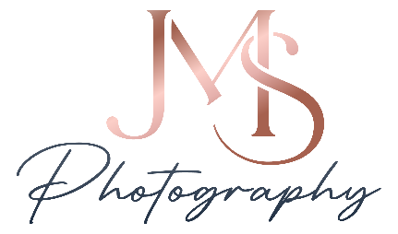
Please fill out 1 form per child.
Child’s Name_________________________________ Teacher/Team_______________________________________
Phone Number____________________________________ Email_________________________________________
__________________________________________________________________________________________________
Please complete the form and attach a cash or check payment with the form. The last 4 numbers of the image should be listed in the blanks.
Collection C - $25
*2, 5x7 Fine Art Metallic Prints
(Image #’s_________ & __________)
*4 Wallets (all the same image) (Image #’s__________)
Collection B - $45
*1, 8x10 Fine Art Metallic Print (Image #______)
*2, 5x7 Fine Art Metallic Prints (Image #’s _________ & _________)
*4 Wallets (all the same image)
(Image #________)
Collection A - $69
*1, High Resolution Printable File (Image #__________)
*1, 8x10 Fine Art Metallic Print (Image #__________)
*1, 5x7 Fine Art Metallic Prints (Image #_________)
*4 Wallets (all same image #) (Image #________)

If you purchase a collection above, you can get the following at a reduced price:
*High Resolution Printable File (digital download) - $25/ea __________________________________________________
*Additional 11x14 Fine Art Metallic Print - $35 ($45 if you don’t purchase a collection) ___________________________
*Additional 8x10 Fine Art Metallic Print - $25 ($35 if you don’t purchase a collection) _____________________________
*Additional 5x7 Fine Art Metallic Print - $12 ($20 if you don’t purchase a collection) ______________________________

A-La-Carte (can be purchased alone, without a collection):
*All high res. printable files of your child (group shots not included, for one child) - $95___________________________
*Button with image - $14ea___________________________________________________________________________
*High Resolution Printable File (digital download of one image) $65ea________________________________________
*Set of 4 Wallets (all the same image) - $14_______________________________________________________________
*Memory Mate (2 images on an 8x10 print) - $28 __________________________________________________________
My total $_______________________
My payment method: Cash Check
**Any other details, instructions or information:_____________________________________________________________________________
____________________________________________________________________________________________________________________

JMSfacephotography.com (270) 556-9443 2830 Lone Oak Rd Suites 3 & 4

